Thejasvenan T. 220638J
ME 2261 - Embedded Systems Log Book
Day 12 – 16.10.2025
USART
Initializing serial port
Set USART for asynchronous mode
Set USART communication parameters (data bits, stop bits, parity bit)
Set baud rate
Enable transmitter and receiver
Initialize serial port of ATmega32A to baud rate 9600 bps, no parity, 1 stop bit, 8 data bits. Assume a clock speed of 8 MHz.
Sending a character
Has UDRE flag (Register UCSRA) been set to 1?
Yes, Write the character to register to UDR for transmission
Receiving a character
Has RXC flag (Register UCSRA) set to 1?
Yes, Read the received character from register UDR
Task 1
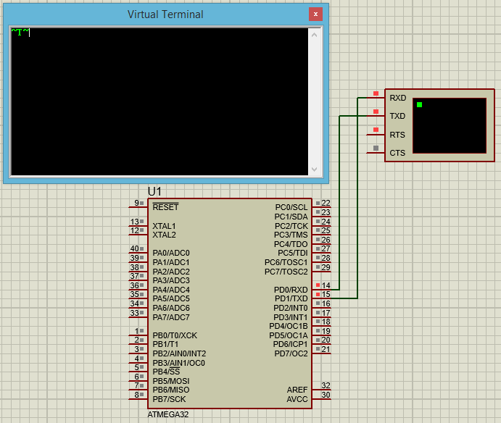
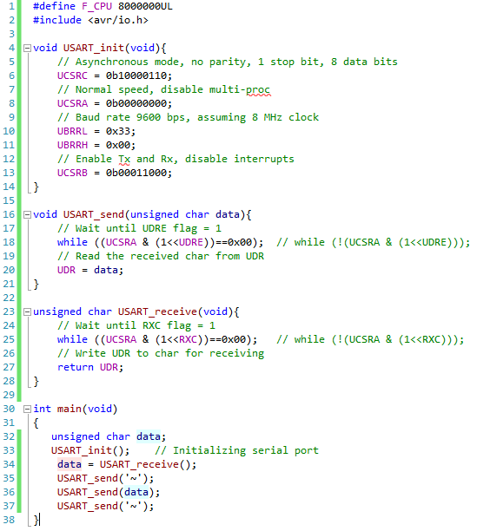

Task 2
Using USART communication interface, write a program to display a message according to the received character.
- If the character ‘M’ is received, send the message “Good Morning”.
- If the character ‘A’ is received, send the message “Good Afternoon”.
- If the character ‘E’ is received, send the message “Good Evening”.
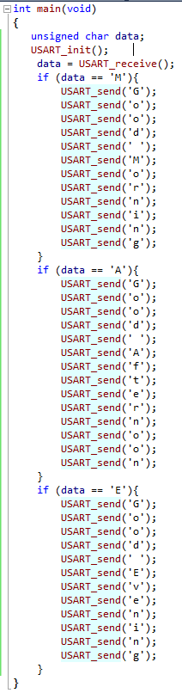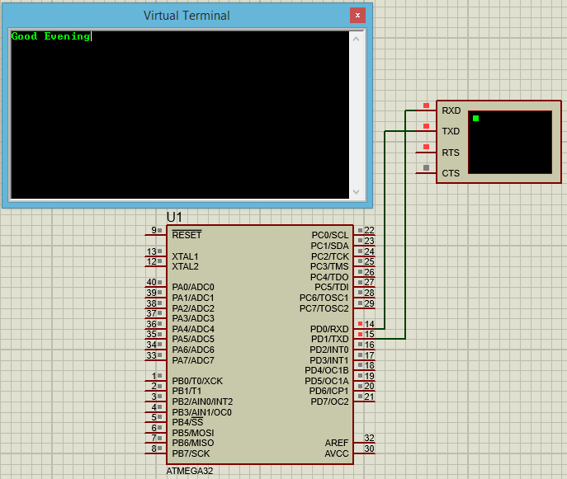

Task 3
Send data from one microcontroller to another microcontroller and display the received message on the LCD screen. (Connect TXD of one to RXD of another using wire)
Follow the same message format as Task 2.
void USART_send(unsigned char data){
// Wait until UDRE flag = 1
while ((UCSRA & (1<<UDRE))==0x00); // while (!(UCSRA & (1<<UDRE)));
// Read the received char from UDR
UDR = data;
}

unsigned char USART_receive(void){
// Wait until RXC flag = 1
while ((UCSRA & (1<<RXC))==0x00); // while (!(UCSRA & (1<<RXC)));
// Write UDR to char for receiving
return UDR;
}

int main(void)
{
unsigned char data;
USART_init();
while(1){
data = USART_receive();
USART_send(data);
}
}

unsigned char USART_receive(void){
// Wait until RXC flag = 1
while ((UCSRA & (1<<RXC))==0x00); // while (!(UCSRA & (1<<RXC)));
// Write UDR to char for receiving
return UDR;
}

int main(void)
{ DDRA = 0xFF;
DDRB = 0xFF;
Lcd8_Init();
unsigned char data;
USART_init();
while (1){
data = USART_receive();
Lcd8_Set_Cursor(1,0);
if (data == 'M')
{
Lcd8_Clear();
Lcd8_Write_String("Good Morning");
}
if (data == 'A')
{
Lcd8_Clear();
Lcd8_Write_String("Good Afternoon");
}
if (data == 'E')
{
Lcd8_Clear();
Lcd8_Write_String("Good Evening");
}
_delay_ms(1000);
}
}
